**U-Access Pantry Information System**

**Requirement Gathering:**

**Sources from requirement gathering:**

* We took an Interview with the program coordinator from U-Access Pantry.
* We created a Google form and took a survey from the student. This is the link for our Google form:

https://forms.gle/M2FEU6wGY5yJBtkq7

* Cost estimation for salary via Google

**Problem Statement:**

* The current procedure is time-consuming.
* Need to improve the management.
* Food Insecurity among the student is not still resolved.

**Functional requirements:**

* Plan to achieve transparency by alert system.
* Plan to implement a grocery store at minimal cost for when donations run out.
* Food insecurity is resolved.

**Solution**:

* We are planning to create a user-friendly App.
* Transparency between the student and the staff
* Alert System: To notify the student of every donation received to the U-access so that they can place the order for the same.
* **Food will be available for the student at the store at a minimal cost in Store.**
* Student Employment is provided.
* Revenue (All the profit from the store) from the store is given to the college.

Below is the survey result from the google form:

1. 93.33% of students are ready to buy groceries from the store.
2. 80% of students experienced Food Insecurity.

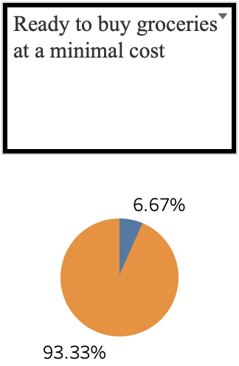

From the above survey, we understood that many students are facing food insecurity. Even if the donation runs out students are not disappointed, they can at least buy the grocery at a minimal cost.

**Business Policy for our System:**

* Student of UMASS
* A single registration can be allowed by a student.
* Per Student one Donation (FIFO). So, most of the students get the benefit of free food.
* Breach of Student Confidentiality will result in a lawsuit.
* Ensuring the safety of the food supply.
* All the hardware issues will be taken care of by the procurement manager
* Failing to collect the order is a penalty to the student.

AS IS Context Diagram:

U-Access Pantry is the System where the students, Staff and Donors are the entities which interact with our system.

To Be Context Diagram:

This diagram is a high-level view of the system we are trying to achieve. As mentioned above the system is the same, but the entities are Students, Staff, Donors, Farmers, and the University.

Level 0 DFD:

At level 0 we have 4 processes namely logging, notification, financing and placing orders. The five entities interact with these processes. The student entity interacts with the system by first logging in then their details are stored in the student members which are pulled by notification for them to receive alerts about donations.

The student entity then places an order to request the food item by interacting with the placing order which is stored in order inventory and is also pulled by notification for the notification process to send alerts to farmers to request to replenish food items for the store.

After ordering the financing process pulls in the order details from the order inventory data store and saves them in the student payment then, these payment details are pulled by the staff to keep the payments in check before handing out the groceries.

The staff also interacts with notifications to send donors emails for donations. And the staff also interacts with financing for the generation of monthly financial reports which are pulled by the university to keep a check on the revenue generated.

Level 1 for Placing Order:

Level 1 for notification:

Level 1 for financing:

Level 1 for Logging:

As Is Use Case:

We have two actors in the current system:

Primary Actor: Student i.e., the initiator

Secondary Actor: U-Access Staff who do all the check-in processes for the system.

We have include for check registered member because the student must to registered before they can get donations.

After checking in they need to fill up the on desk form post which the secondary actor can get them the groceries.

To be Use Case:

We plan to keep the registration of the students as it is but on the ne developed system.  
Also once the primary actor (the student) is a registered student, they would be able to place their order directly on the system and checkout, with payment as include extension as they would be liable to pay for the groceries they buy. Also they have an ‘option’ of checking the donations that they can take (upto one bag) which is of course first come first serve basis.   
As the university would be funding the project with inhouse recruiters they would be sent a monthly report of the profits made by the Uaccess grocery store.   
Also The famers and donors would be sent alerts whenever the inventory has run out and also the student would get alerts for whenever the inventory is replenished.

